REVIEW / RESEARCH ARTICLE / INTERVIEW / OPINION / REPORT

Title
  - Title in Brazilian Portuguese
ABSTRACT: The abstract should have at least 100 and up to 250 words. It should precisely state the article’s goal/s, methods, results, and conclusions. Avoid using acronyms, symbols, formulas, diagrams etc.
Keywords: Al least three up to five Keywords separated by semicolon.
RESUMO: Insert here the abstract translated to Brazilian Portuguese.
Palavras-chave: Insert here the keywords translated to Brazilian Portuguese.

HEADING 1
This is a sample text, please replace it with the manuscript’s text, keeping the formatting.

HEADING 1
This is a sample text, please replace it with the manuscript’s text, keeping the formatting.

Heading 2
This is a sample text, please replace it with the manuscript’s text, keeping the formatting.
Citations and references should be formatted according to ISO 690:2010 author-date style. Some examples of formatting for the most common types of sources are available at the end of this template.
When presenting numerical data in tables, do not apply table’s left and right borders, e.g.:
Table 1. Listing of the phenomena observed in the study.
 | Variable 1 | Variable 2 | Variable 3 | Total
Observation 1 | 5 | 10 | 6 | 21
Observation 2 | 4 | 8 | 12 | 24
Observation 3 | 10 | 5 | 9 | 24
Observation 4 | 7 | 2 | 12 | 21

When presenting textual data, please apply all the outer borders to each table, e.g.:
Table 2. Dimensions observed in the study.
Dimensions | Description... | Description...
Dimension 1 | Description text... | Description text...
Dimension 2 | Description text... | Description text...

Heading 3
This is a sample text, please replace it with the manuscript’s text, keeping the formatting.
Figure 1. Phenomena observed in the study.
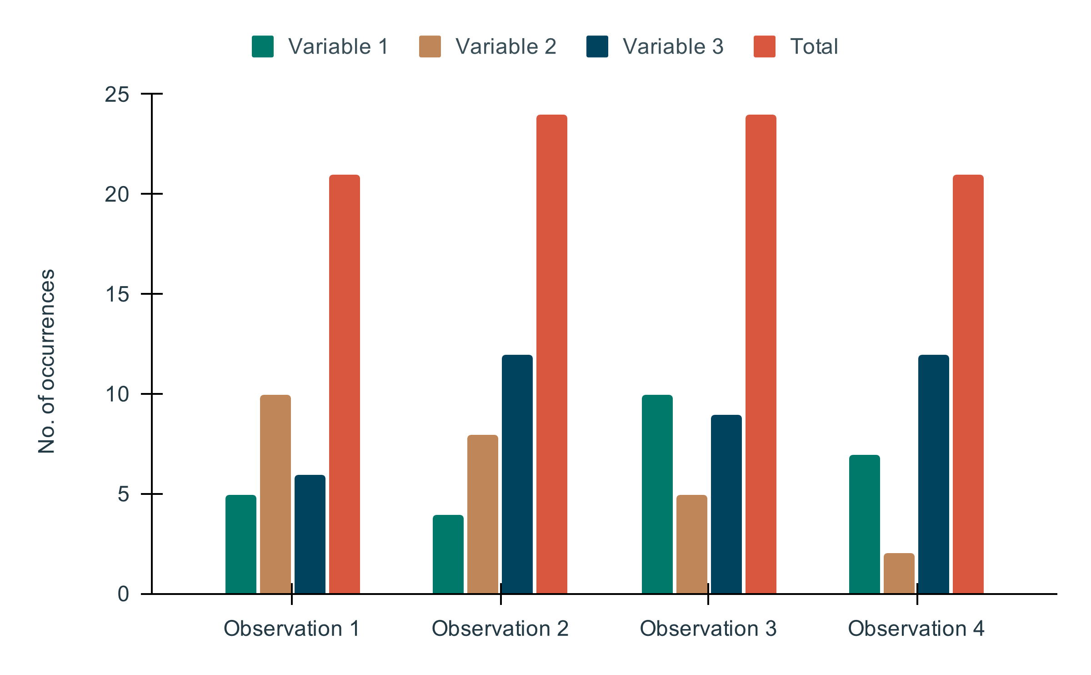
Figures, charts, tables, and other types of illustrations, whenever possible, should be presented in an editable or vector format, that is, in the same format of the program in which they were created/edited. As for photographs or digitalized images, those should be presented with a minimum resolution of 300dpi. The source of each illustration would be presented below it on the manuscript’s text.

HEADING 1
This is a sample text, please replace it with the manuscript’s text, keeping the formatting.

ACKNOWLEDGMENTS
If available, should be succinct, referring to people or institutions.

FUNDING
Section for the designation of the study’s funding sources. Should list each funding institution's names, without abbreviations, and, if available, the funding/grant number.

DATA AVAILABILITY
Data availability statement example:
“The entire data set/ software supporting the results and the analyses of this study was made available in [repository name] and can be accessed in [URL or unique identifier].”

REFERENCES
References should be formatted according to ISO 690: 2010 author-date. Keep them aligned to the left margin, with each reference separated by a single space (12 points). Some examples:
ALBORNOZ, Denisse Alejandra, 2017. Power and inequality in open science discourses. Medium [online]. 20 November 2017. [Accessed 23 November 2017]. Available from: https://medium.com/@denalbz/power-and-inequality-in-open-science-discourses-9d425b0c2b63
ALPERIN, Juan Pablo, FISCHMAN, Gustavo and WILLINSKY, John, 2008. Open access and scholarly publishing in Latin America: ten flavours and a few reflections. Liinc em Revista [online]. 2008. Vol. 4, no. 2, p. 172–185. [Accessed 8 March 2017]. DOI 10.18617/liinc.v4i2.269. Available from: http://dx.doi.org/10.18617/liinc.v4i2.269
BERNAL, John Desmond, 1939. Social function of Science [online]. London, England: Lowe and Brydone. [Accessed 4 May 2019]. Available from: https://archive.org/details/in.ernet.dli.2015.49995
BOURDIEU, Pierre, 1983. O campo científico. In: ORTIZ, Renato (ed.), Bourdieu: sociologia. São Paulo, SP: Ática. p. 122–155.
EVE, Martin Paul, 2020. Some tips on writing a data management plan for the humanities. Twitter: @martin_eve [online]. 11 February 2020. [Accessed 11 February 2020]. Available from: https://twitter.com/martin_eve/status/1227240006344835073
GONZÁLEZ DE GÓMEZ, Maria Nélida, 2013. Sobre normas e algoritmos: os critérios de validade da ciência e da informação. In: Encontro Nacional de Pesquisa em Ciência da Informação [online]. Florianópolis, SC: Ancib; UFSC. 2013. [Accessed 1 November 2015]. 16. Available from: http://repositorio.ibict.br/handle/123456789/463
GUÉDON, Jean-Claude, 2010. Acesso aberto e divisão entre ciência predominante e ciência periférica. In: FERREIRA, Sueli Mara Soares Pinto and TARGINO, Maria das Graças (eds.), Acessibilidade e visibilidade de revistas científicas eletrônicas. São Paulo, SP: Cengage Learning; Senac. p. 21–78.
HESS, Charlotte, 2008. Mapping the new commons. In: Proceedings of the Biennial Conference of the International Association for the Study of the Commons [online]. Cheltenham, UK: SSRN. 2008. p. 14–18. [Accessed 26 June 2017]. Available from: https://papers.ssrn.com/sol3/papers.cfm?abstract_id=1356835
MOURA, Maria Aparecida, 2009. Informação e conhecimento em redes virtuais de cooperação científica: necessidades, ferramentas e usos. DataGramaZero: Revista de Ciência da Informação [online]. 2009. Vol. 10, no. 2. [Accessed 8 June 2020]. Available from: https://brapci.inf.br/index.php/article/download/7591
POMBO, Olga, 2005. Interdisciplinaridade e integração dos saberes. Liinc em Revista [online]. 2005. Vol. 1, no. 2, p. 3–15. [Accessed 8 June 2020]. DOI 10.18617/liinc.v1i1.186. Available from: http://revista.ibict.br/liinc/article/view/3082
SANTOS, Mílton, 2004. Por otra globalización: del pensamiento único a la conciencia universal. Bogotá, Colômbia: Convenio Andrés Bello.
SILVEIRA, Sergio Amadeu and SAVAZONI, Rodrigo Tarchiani, 2018. O conceito do comum: apontamentos introdutórios. Liinc em Revista [online]. 5 June 2018. Vol. 14, no. 1, p. 5–18. [Accessed 23 April 2020]. DOI 10.18617/liinc.v14i1.4150. Available from: http://revista.ibict.br/liinc/article/view/4150
VESSURI, Hebe, GUÉDON, Jean-Claude and CETTO, Ana María, 2014. Excellence or quality? Impact of the current competition regime on science and scientific publishing in Latin America and its implications for development. BEIGEL, Fernanda (ed.), Current Sociology [online]. 4 September 2014. Vol. 62, no. 5, p. 647–665. DOI 10.1177/0011392113512839. Available from: https://journals.sagepub.com/doi/10.1177/0011392113512839
WEITZEL, Simone da Rocha, 2006. Os repositórios de e-prints como nova forma de organização da produção científica: o caso da área das Ciências da Comunicação no Brasil [online]. Tese (Doutorado em Comunicação). São Paulo, SP: Universidade de São Paulo. [Accessed 6 March 2017]. Available from: https://teses.usp.br/teses/disponiveis/27/27151/tde-14052009-133509/pt-br.php

